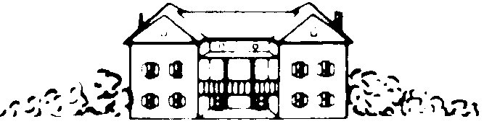

Mount Vernon Hotel Museum & Garden
421 East 61st Street · New York, NY 10065
Phone (212) 838-6878 ext. 26· Fax (212) 838-7390

History Weeks Registration Form 2017

Camp Session (please mark): #1 July 10-14 (ages 9-12) #2 July 17-21 (ages 6-8)

Camper Name: Present Age:

Birth Date: Gender: Male / Female Returning Camper: Yes / No

Parent/Guardian Name: Email:

Address: City: State: ZIP:

Home #: Work Phone #: Cell Phone #:

Best way to reach you during program hours? Home / Work / Cell

Local emergency contact other than parent/guardian(s) listed:

Name: Relationship: Phone #:

Others authorized to pick up your child:

Name: Relationship: Phone#:

Name: Relationship: Phone #:

Name: Relationship: Phone #:

Payment Information
Are you a MVHMG Family Member? Yes / No | T- Shirt Size: Child Small __ Medium __ Large__  Adult Small __ Medium __ Large__
Session #1 Rates:
Members: $250.00 ($225 Early Bird by May 1)/ Non-Members: $275.00 ($250 Early Bird by May 1)

Session #2 Rates:
Members $180.00 ($155 Early Bird by May 1)/ Non-Members: $200.00 ($175 Early Bird by May 1)

Check payable to Mount Vernon Hotel Museum & Garden
Credit card (circle) VISA MASTERCARD DISCOVER

Name on Card (please print):

Account Number: Expiration Date: Zip Code:

Signature: Date:

Please send form to Natalia Sokolova, Curator of Education, via fax or mail using the information above, or by email to n.sokolova@mvhm.org. Medical and other forms will follow via email.

